Trip Report – Inaugural APBA Conference, Accra, Ghana, Oct. 23-25, 2019
Donn Cummings, NAPB Borlaug Scholars Chair

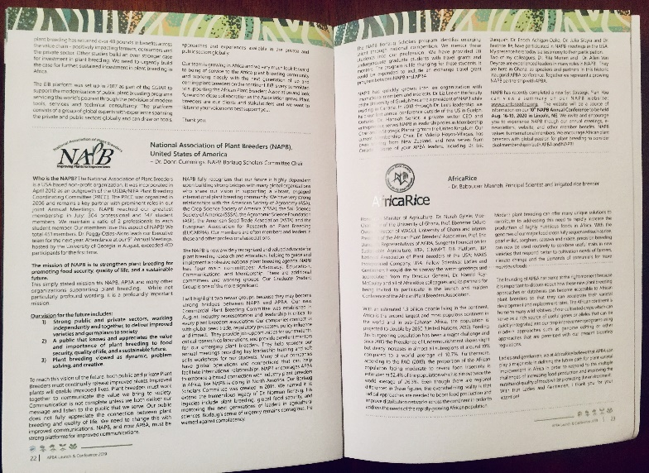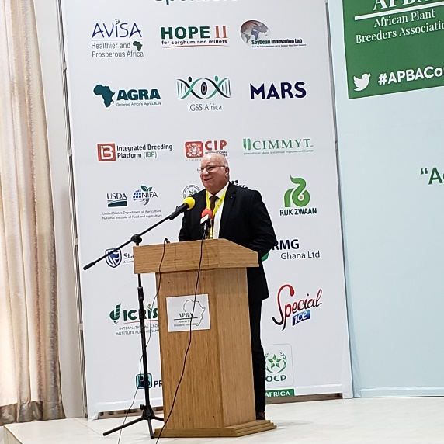
NAPB was one of 10 partner organizations privileged to publish a goodwill message in the proceedings and to have an invited speaker to deliver a goodwill message during the opening ceremonies. Dr. Donn Cummings represented NAPB, supported by Dr. Rita Mumm, NAPB Past President (2012) and Dr. Allen Van Deynze, NAPB Borlaug Scholars Secretary and Annual Meeting Planning Committee Chair (2017). Rita was a Keynote speaker and Allen was a Plenary Session speaker at APBA. Prior work in Africa by Rita and Allen has set the stage for a strong presence of NAPB to partner with and support APBA. Dr. Ann Marie Thro, USDA/NIFA (retired) represented NAPB in the proceedings booklet with a personal message that was printed on a page by itself, in her honor, and was highlighted from the podium by Professor Eric Danqua. The high profile of NAPB at the inaugural conference of APBA was humbling, but wonderful to experience firsthand. Other Goodwill organizations/messages included:
AGRA - Dr. Agnes Kailbata, President
MARS Incorporated – Dr. Howard-Yana Shipiro, Chief Agricultural Officer
IITA – Dr. Michael Abberton, Head of Genetic Resource Centre
CIMMYT – Dr. Boddupalli M. Prasanna, Director of CIMMYT’s Global Maize Program and the CGIAR Research Program on Maize
CIP/CGIAR – Dr. Maria Andrade, CIP Sweetpotato Breeder and World Food Prize co-laureate and Graham Thiele, Director CGIAR Research Program on Roots, Tubers, and Bananas
Syngenta Foundation – Dr. Vivienne Anthony, Senior Scientific Advisor
IBP – Dr. Jean-Marcel Ribaut, Director
EiB – Dr. Biswanath Das, EiB NARs Coordinator & Programming Lead
Africa Rice – Dr. Baboucarr Manneh, Principal Scientist and Irrigated Rice Breeder
The special consideration given to NAPB in opening ceremonies enabled extraordinary presence throughout the conference. It established NAPB as a valued sister organization for the future of APBA. We should not take for granted the partnership potential between NAPB and APBA for supporting the growth of both associations. Side conversations with APBA leadership enabled valuable conversations to share experiences and helpful guidance and ideas. This interaction is invaluable and only occurs with direct participation and attendance at each other’s meetings.
The West African Centre for Crop Improvement (WACCI) hosted the 3-day event on campus at the University of Ghana. The conference attracted 421 registrants. Participants arrived from 30 countries for APBA. Female scientists made up 40%. It included 5 Keynotes, 10 Plenary and 72 Scientific presentations. There were at least 10 partner institutions, 21 sponsors, and 6 booth spaces. There were 163 posters listed in the proceedings.
During the business meeting the interim executive team was voted in as official officers of APBA and the constitution was approved with a short window for additional suggestions for final edits.
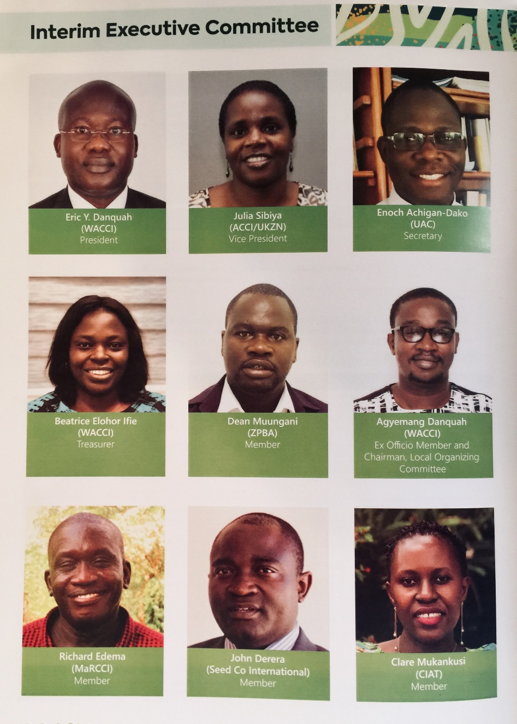
The next conference of APBA is planned for 2021 at Makerere University in Uganda hosted by the Makerere University Regional Center for Crop Improvement (MARCCI). Please check out this video promoting MARCCI: MaRCCI The Beginning Final(B).mp4 This video should be shown at 2020 NAPB conference in Lincoln, NE. Attached to the email with this report is a PowerPoint slide deck that can also be a resource for NAPB 2020 meetings. The slides were used by Dr. Richard Edema, Director of MaRCCI, to invite participation in APBA in 2021. Future planning for NAPB participation in APBA 2021 can be directed to:
Dr.Richard Edema, Director
Makerere University Regional Center for Crop Improvement (MaRCCI)
College of Agricultural and Environmental Sciences
Makerere University
P.O. Box 7062,Kampala, Uganda
Mobile :+256-79-3-529838
:+256-78-1-735049
Phone :+256-41-4-533580
Web: www.makplantbreeding.org
Email: redema12@yahoo.com;
During the first day of the APBA conference a smaller group of participants were invited to attend the Inauguration of the Kofi Annan Enterprise Hub for Agricultural Innovation (KAEHAI), a modern center for developing youth for future roles in developing agricultural start-ups and partnerships with private sector participants. This will be a key connection point for public-private-government interactions.
The new African Plant Breeders Association demonstrated tremendous momentum coming out of the inaugural conference which was highly organized and effectively and efficiently executed. Memberships are being processed. Fee for professional membership is $100 USD. Students pay $30. There is a loosely defined Affiliate Membership level of $50 to encourage broader participation beyond plant breeders. This is an interesting concept worthy of discussion in NAPB membership committee.
APBA is off to a great start, but need much support between conferences to keep people engaged. APBA needs to incorporate, cannot currently accept credit cards, and has a few other start-up challenges to face in the short term. One challenge is deciding committee structure and involving more countries through committee leadership involvement.
Student participation was high at the initial conference. Individual institutions were able to sponsor their own students, but there is opportunity to develop a travel grant/mentoring program. It is not clear that institutions could send that number of students on an ongoing basis without additional support. The students were impressive and enthusiastic.
Several people approached me about joining NAPB. It is possible we could see some new NAPB members from Africa. NAPB meeting date cards were placed on a display table and were readily picked up by attendees. Several indicated desire to attend our 2020 NAPB Nebraska meetings, but it is not possible for many. Any enabling help would be greatly appreciated and would benefit both NAPB and APBA.
A joint poster/flyer was developed showing instructions for joining both NAPB and APBA for distribution in both North America and Africa through social media and/or event venues. This demonstrated a desire for enhance partnership between these two sister associations and encourages global plant breeders to consider dual memberships. A file with this promotional piece was sent to Africa and is being distributed. It will be presented at poster session on Nov. 8th at a Purdue University. The file is attached to the email containing this report.
I wish to thank the NAPB executive committee for enabling my trip to be a liaison between NAPB and APBA. Having the backing from NAPB greatly enhanced my attendance at this historic event! I delight in bringing this report of great things happening in Plant Breeding in Africa for Africa!

A New Heart
is Beating
in Africa!

